EITS Site Inspector Dashboard User Guide

**1. Overview**

The Site Inspector Dashboard allows inspectors to organize the site data at one place so that it can be easily accessible and the client receive the best services. It allows Site Inspector to:

• Record and manage site-related information  
• Upload photos, audio notes, and measurements  
• Track work progress using status cards

How To Open Main Inspection Page?

* First click on Hamburger Icon
* Then Click on Inspections button



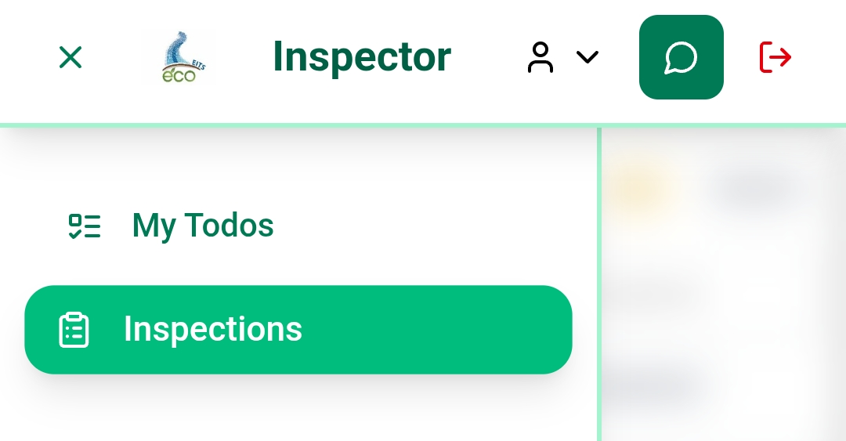

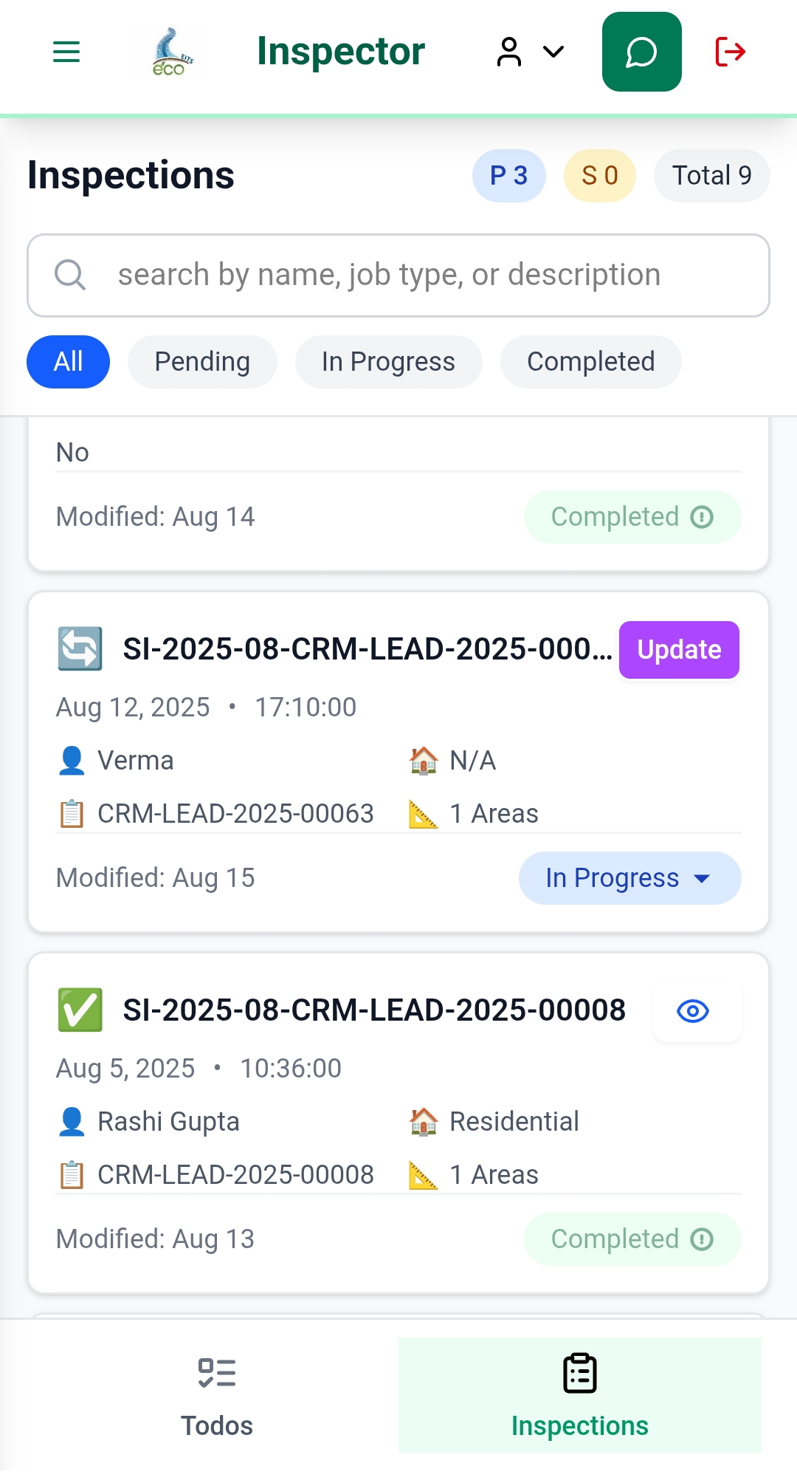

**2. Dashboard Structure**

## Types of Cards

There are to types of Cards one is the working card and another is the site inspection is completed

• Working Card – Displays ongoing tasks. Inspectors can update the progress of site activities.  
• Completed Card – Shows finished tasks and inspection details.

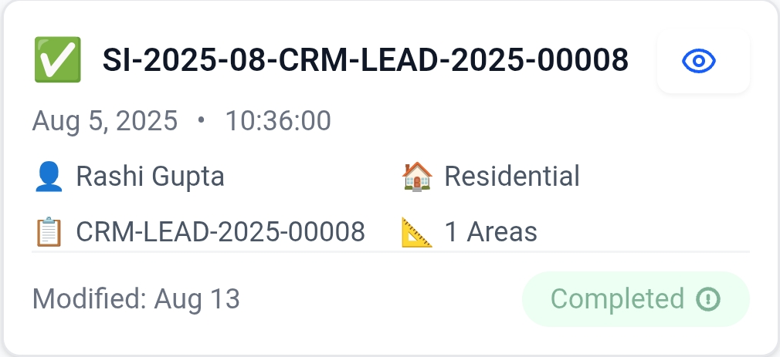

**Completed Card**

**Update Button**

When you click the Update button, you can:  
• View inspection details  
• Check upcoming site visit schedules  
• Modify progress and related notes

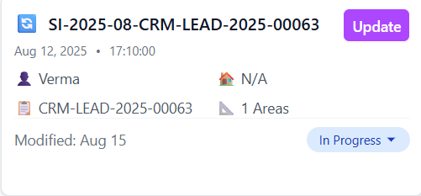

* The second card is the work is in progress or other steps.
* Now Site inspector can change the work process by Selecting the following steps.

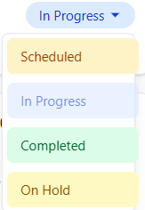

As you click on update button the first section you can see is Inspection Details.

In Inspection details site inspector can when they need to visit the site and gather the site data.

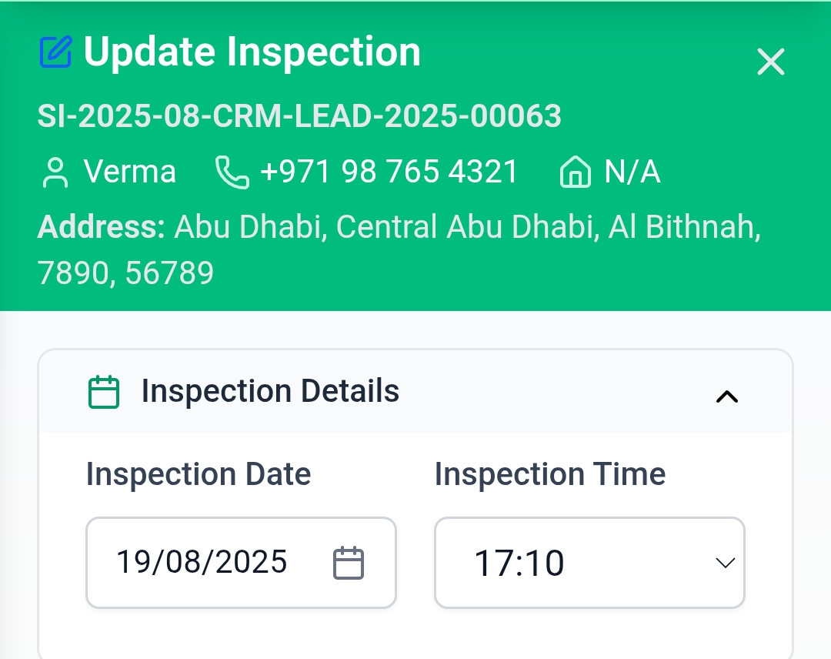

**3. Site Dimensions Section**

In the Site Dimensions module, inspectors can:

* In dimension section site inspector can enter the Area, measurement of the site.
* Add part-specific dimensions.
* Attach photos and voice notes for better understanding.
* If necessary, add more dimensions too.

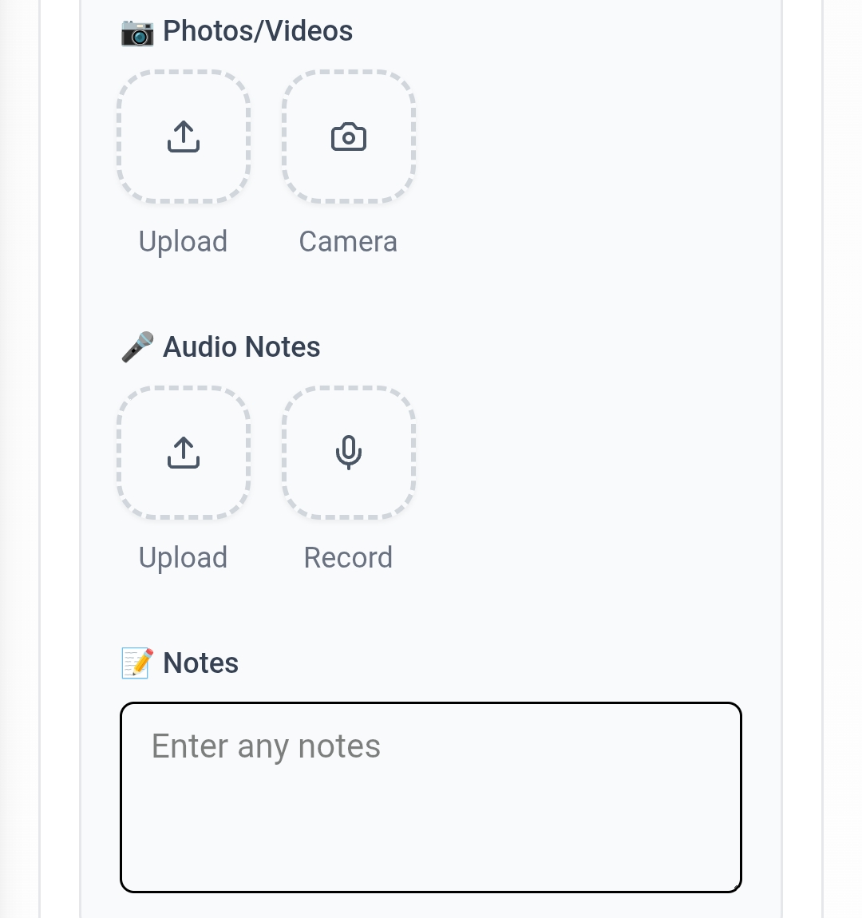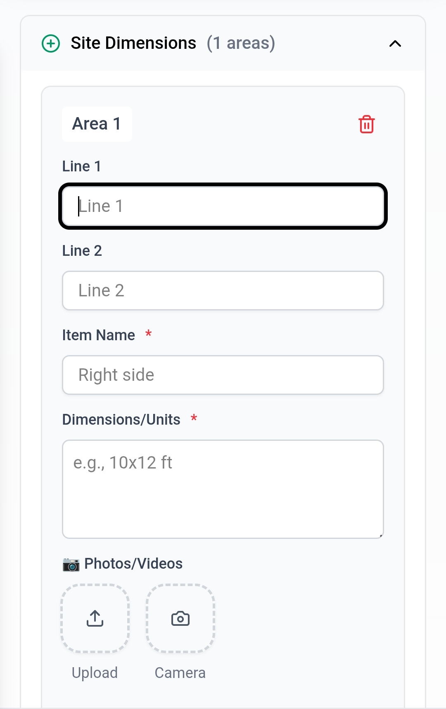

**4. Custom Media & Sketches**

• Upload additional images for reference  
• Add custom sketches to represent dimensions or work areas  
• Attach media files to support inspection reports

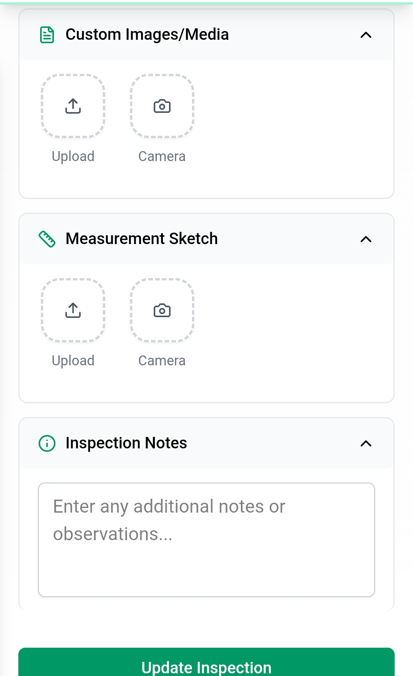

**5. Key Benefits**

✔ Centralized storage of inspection details  
✔ Easy progress tracking with status cards  
✔ Visual documentation with photos, sketches, and voice notes  
✔ Clear inspection timelines and site visit planning

**Document Title:** EITS Site Inspector User Guide

* **Package Number:** 001
* **Author:** Kartik Kumar, Atul Raj
* **Approved By:** Amit Gupta
* **Created Date:** [18/08/2025]
* **Last Updated:** [18/08/2025]
* **Version:** 1.0.0
* **Status:** Draft
* **Confidentiality Level:** Internal Use
* **Developed at:** Gennext IT Management & Consulting